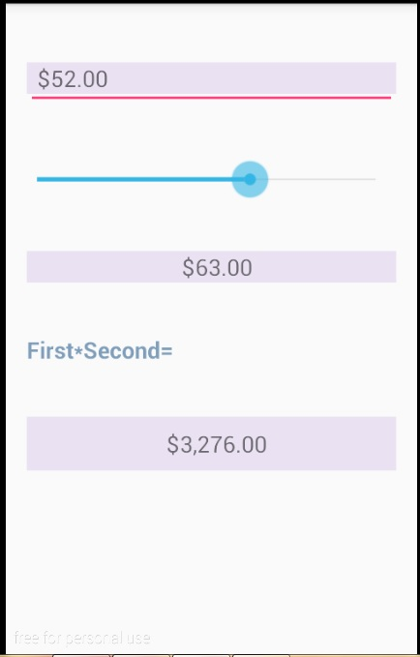

*<?***xml version="1.0" encoding="utf-8"***?>*<**GridLayout  
 xmlns:android="http://schemas.android.com/apk/res/android"  
 xmlns:app="http://schemas.android.com/apk/res-auto"  
 xmlns:tools="http://schemas.android.com/tools"  
 android:layout_width="match_parent"  
 android:layout_height="match_parent"  
 android:fitsSystemWindows="true"  
 android:paddingLeft="@dimen/activity_horizontal_margin"  
 android:paddingRight="@dimen/activity_horizontal_margin"  
 android:paddingTop="@dimen/activity_vertical_margin"  
 android:paddingBottom="@dimen/activity_vertical_margin"  
 tools:context=".MainActivity"  
 android:columnCount="1"  
 android:rowCount="5"  
 android:orientation="horizontal"** >

<**EditText  
 android:layout_width="match_parent"  
 android:layout_height="wrap_content"  
 android:inputType="number"  
 android:layout_gravity="fill_horizontal"  
 android:digits="0123456789"  
 android:maxLength="6"  
 android:layout_marginTop="20dp"  
 android:layout_row="0"  
 android:layout_column="0"  
 android:id="@+id/numEditText"** />  
  
 <**TextView  
 android:layout_width="wrap_content"  
 android:layout_height="wrap_content"  
 android:textAppearance="?android:attr/textAppearanceMedium"  
 android:id="@+id/firstNumberTextView"  
 android:layout_column="0"  
 android:layout_row="0"  
 android:layout_gravity="fill_horizontal"  
 android:background="#eae2f2"  
 android:layout_marginTop="20dp"  
 android:paddingLeft="8dp"  
 android:text="@string/firstNumber"** />  
 <**SeekBar  
 android:layout_width="match_parent"  
 android:layout_height="wrap_content"  
 android:id="@+id/secNumSeekBar"  
 android:max="100"  
 android:progress="50"  
 android:indeterminate="false"  
 android:layout_gravity="fill_horizontal"  
 android:layout_column="0"  
 android:layout_row="1"  
 android:layout_marginTop="40dp"  
 android:paddingLeft="8dp"  
 android:mirrorForRtl="false"** />  
  
 <**TextView  
 android:layout_width="match_parent"  
 android:layout_height="wrap_content"  
 android:textAppearance="?android:attr/textAppearanceMedium"  
 android:id="@+id/secValueTextView"  
 android:layout_weight="1"  
 android:background="#eae2f2"  
 android:gravity="center"  
 android:layout_column="0"  
 android:layout_row="2"  
 android:layout_marginTop="40dp"  
 android:layout_gravity="fill_horizontal"  
 android:text="@string/sec"  
 android:paddingLeft="8dp"** />  
  
  
 <**TextView  
 android:layout_width="wrap_content"  
 android:layout_height="wrap_content"  
 android:textAppearance="?android:attr/textAppearanceMedium"  
 android:text="@string/fs"  
 android:layout_column="0"  
 android:layout_row="3"  
 android:layout_marginTop="40dp"  
 android:textColor="#7f9ebb"  
 android:textStyle="bold"  
 android:id="@+id/labelTextView"** />  
  
 <**TextView  
 android:layout_width="match_parent"  
 android:layout_height="42dp"  
 android:textAppearance="?android:attr/textAppearanceMedium"  
 android:layout_weight="1"  
 android:background="#eae2f2"  
 android:gravity="center"  
 android:layout_column="0"  
 android:layout_row="4"  
 android:layout_marginTop="40dp"  
 android:layout_gravity="fill_horizontal"  
 android:paddingLeft="8dp"  
 android:id="@+id/fsTextView"** />  
  
  
</**GridLayout**>

**package** com.example.hayaalhunataity.cal;  
  
**import** android.os.Bundle;  
**import** android.support.v7.app.AppCompatActivity;  
**import** android.text.Editable;  
**import** android.text.TextWatcher;  
**import** android.widget.EditText;  
**import** android.widget.SeekBar;  
**import** android.widget.TextView;  
**import** java.text.NumberFormat;  
  
**public class** MainActivity **extends** AppCompatActivity {  
  
 **private static final** NumberFormat ***firstNumFormat*** = NumberFormat.*getCurrencyInstance*();  
 **private static final** NumberFormat ***secNumFormat*** = NumberFormat.*getCurrencyInstance*();  
  
 **private double firstNum** = 0.0;  
 **private double secNum** = 50.0;  
 **private** TextView **firstNumberTextView**;  
 **private** TextView **fsTextView**;  
 **private** TextView **secValueTextView**;  
  
 @Override  
 **protected void** onCreate(Bundle savedInstanceState) {  
 **super**.onCreate(savedInstanceState);  
 setContentView(R.layout.***activity_main***);  
  
 **firstNumberTextView** = (TextView) findViewById(R.id.***firstNumberTextView***);  
 **secValueTextView** = (TextView) findViewById(R.id.***secValueTextView***);  
 **fsTextView** = (TextView) findViewById(R.id.***fsTextView***);  
  
 **firstNumberTextView**.setText((***firstNumFormat***.format(**firstNum**)));  
 updateNum();  
  
 EditText numberEditText= (EditText) findViewById(R.id.***numEditText***);  
 numberEditText.addTextChangedListener(**numberEditTextWatcher**);  
  
 SeekBar secNumSeekBar = (SeekBar) findViewById(R.id.***secNumSeekBar***);  
 secNumSeekBar.setOnSeekBarChangeListener(**secNumSeekBarListener**);  
 }  
  
  
 **private void** updateNum() {  
 **secValueTextView**.setText(***secNumFormat***.format(**secNum**));  
 cal(**firstNum**, **secNum**);  
  
 }  
 **private void** cal(**double** first,**double** second){  
 **double** multiResult = first * second;  
 **fsTextView**.setText(***firstNumFormat***.format(multiResult));  
 }  
  
  
  
 **private** SeekBar.OnSeekBarChangeListener **secNumSeekBarListener** = **new** SeekBar.OnSeekBarChangeListener() {  
 @Override  
 **public void** onProgressChanged(SeekBar seekBar, **int** progress, **boolean** fromUser) {  
 **secNum** = progress;  
 updateNum();  
 }  
  
 @Override  
 **public void** onStartTrackingTouch(SeekBar seekBar) {  
  
 }  
  
 @Override  
 **public void** onStopTrackingTouch(SeekBar seekBar) {  
  
 }  
 };  
  
 **private** TextWatcher **numberEditTextWatcher** = **new** TextWatcher() {  
 @Override  
 **public void** beforeTextChanged(CharSequence s, **int** start, **int** count, **int** after) {  
  
 }  
  
 @Override  
 **public void** onTextChanged(CharSequence s, **int** start, **int** before, **int** count) {  
 **try** {  
 **firstNum** = Double.*parseDouble*(s.toString());  
 } **catch** (NumberFormatException e) {  
 **firstNum**=0.0;  
 }  
 **firstNumberTextView**.setText(***firstNumFormat***.format(**firstNum**));  
 updateNum();  
  
 }  
  
 @Override  
 **public void** afterTextChanged(Editable s) {  
  
 }  
 };  
  
  
  
}